Classification of Brain Tumours Using MRI Image Scans

***Shree Krishna Ganguri,***

***The AI Club,***

[***shreekrishna.ganguri@gmail.com***](mailto:shreekrishna.ganguri@gmail.com)***.***

**Abstract**: Brain Tumours impact over 90,000 people globally per year causing approxiametly 17,000 deaths. Over 24,000 Brain Tumours go undetected every year. Early prediction is crucial for effective treatment.There have been many hurdles in the early detection of Brain Tumours, before the treatment becomes ineffective. Current diagnosis methods face challenges such as concealment of the tumour, imaging limitations, issues of visualising small or deep seated tumours, difficulties in distinguishing tumour types, invasive procedures associated with risks, and the heterogeneity of the Brain Tumours .Brain Tumour detection can significantly benefit from AI and ML Algorithms. Our work investigates machine learning for Brain Tumour Identification.To mitigate these obstacles we have collected 3185 MRI(Magnetic Resonance Imaging) scan images which have been classified into 4 different types: Glioma Tumour, Meningioma Tumour, Pituitary Tumour ,and No Tumour. After splitting the images, using 80% for training, 10% for testing, and 10% for validation, we first used MobileNetV2 and used ResNet50V2 to train the AI Model with the training dataset. Using MobileNetV2 the Model was able to correctly distinguish between different types of Brain Tumours with 91.78% accuracy.

**Introduction**: Approximately 17,000 people die each year from malignant brain tumours, highlighting the significant health risks associated with them. One of the primary challenges is that brain tumours often remain undetected until they reach an advanced stage. For instance, slow-growing meningioma tumours may go unnoticed until they begin affecting surrounding tissues, leading to a mortality rate of 65%.

Early detection is crucial for effective treatment, yet it is hindered by factors such as tumour concealment, imaging limitations, difficulty in visualising small or deeply located tumours, challenges in distinguishing tumour types, invasive procedures with associated risks, and the diverse nature of brain tumours.

Training artificial intelligence (AI) and machine learning (ML) algorithms to identify brain tumours presents a promising solution. By analysing MRI scans, these algorithms can detect tumours that might otherwise go unnoticed, potentially reducing the number of undetected brain tumours and preventing unnecessary deaths.

**Materials and Methodology:** Leveraging the use of already widely available and reliable datasets of MRI(Magnetic Resonance Imaging) scans of Brain Tumours, we used 3185 images which have been classified into Glioma Tumour , Meningioma Tumour, Pituitary Tumour, and No Tumour. Then we split the dataset into 3 parts: 80% for Training, 10% for Testing , and 10% for Validation. Then we did extensive training using MobileNetV2 and ResNet50 using different combinations of Epochs and Learning Rate. It took around 1 minute to train each epoch using MobileNetV2 and around 9 minutes for ResNet50. MobileNetV2 gave 91.87% accuracy while using significantly less GPU resources. After conducting all the experiments we concluded that using 30 Epochs and a learning rate of 0.01 with MobileNetV2 gives the best accuracy. We then used the validation split to further train the data and see how it's making predictions for more fine tuning. Observing the confusion matrix we can see that there is no data skew and it is making accurate predictions all round.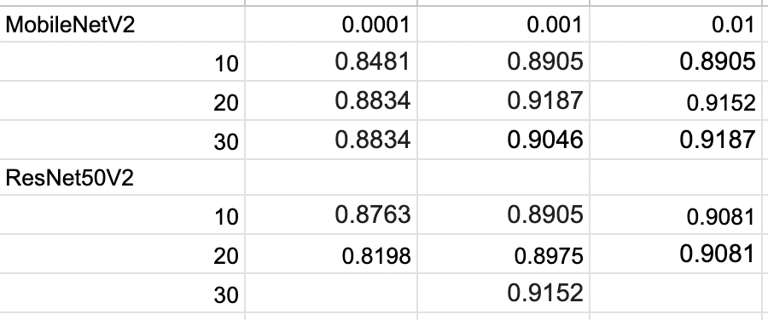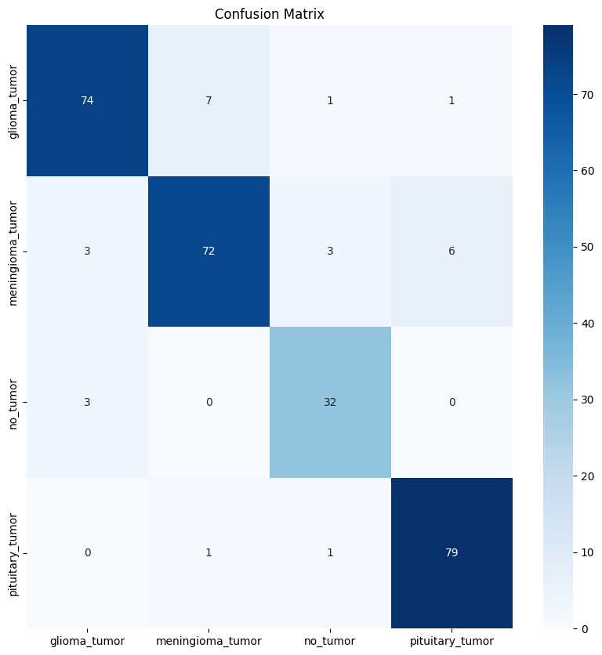

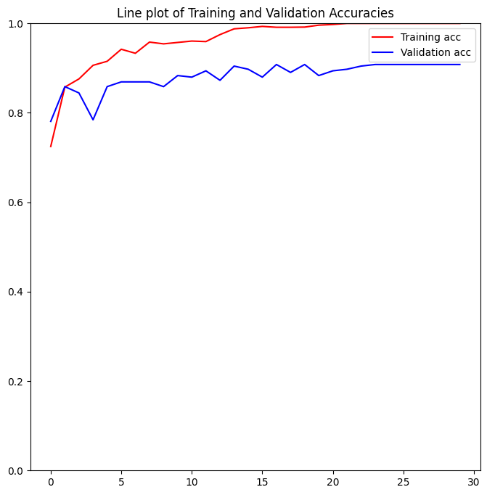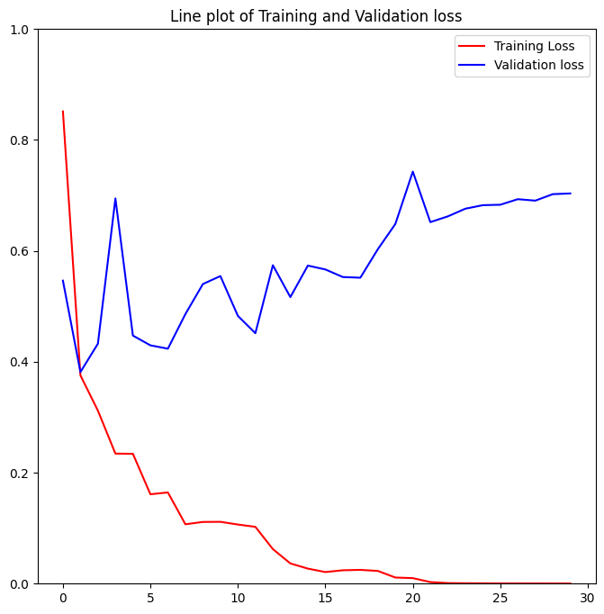

**Results:** Upon evaluating the AI Model using the testing split, we utilised the Confusion Matrix to assess its performance in identifying brain tumours accurately and impartially. The results indicate that the model achieves a high level of precision across various classes. Specifically, Class 0 (Glioma Tumour) and Class 3 (Pituitary Tumour) exhibit both high precision and recall, highlighting the model's robust capability in correctly identifying these types of tumours.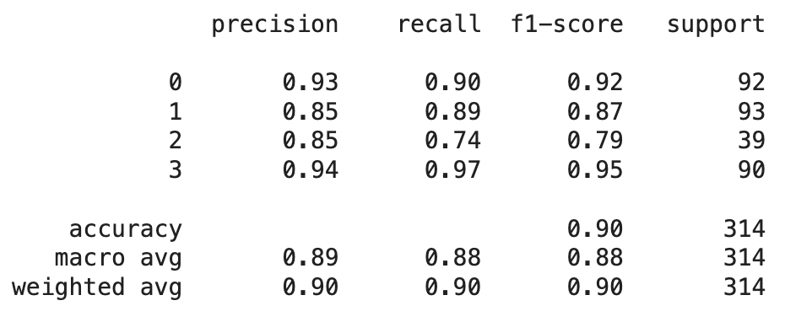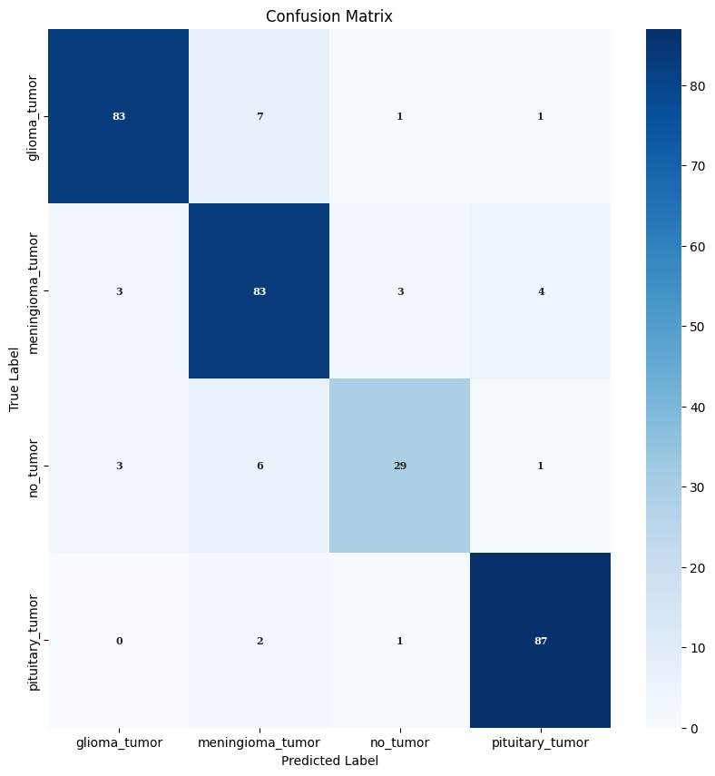

In contrast, Class 2 (No Tumour) shows comparatively lower precision and recall rates, suggesting that the model faces greater difficulty in accurately classifying cases where no tumour is present. This insight provides a clear direction for potential improvements in the model's training or feature selection specific to this class.

The overall accuracy of 90%, as indicated by the classification report, underscores the model's strong performance across all evaluated classes. Moreover, the consistently high weighted average metrics (precision, recall, F1-score), each at 0.90, affirm the reliability and effectiveness of the AI Model in its comprehensive assessment of brain tumour cases.

In practical terms, these findings support the AI Model's role as a valuable tool for oncologists, aiding them in the detection and precise identification of brain tumours. By leveraging this technology, healthcare professionals can potentially mitigate the incidence of undetected brain tumours, leading to earlier interventions and improved patient outcomes on a global scale.

**Limitations:** While the model boasts an accuracy of over 90%, it should not be relied upon as the sole decision-maker for identifying brain tumours. Instead, it should be utilised as a supplementary tool under the supervision of doctors. Furthermore, as indicated by the classification report, the model encounters difficulties with class 2 (No Tumour).

**Further Discussion:** To achieve greater accuracy, especially for Class 2 (No Tumour), we recognize the critical need to expand our dataset. By inviting doctors from around the world to contribute their MRI scans and diagnoses, we can significantly enhance the robustness of our algorithm. This collaborative effort will allow us to retrain our system with a more diverse and comprehensive dataset, thereby improving its ability to accurately identify cases with no tumours.

The potential impact of this advancement is profound. With an enhanced algorithm, we can further reduce the incidence of misdiagnosis and unnecessary treatments, ultimately leading to a reduction in mortality rates associated with brain tumours. Our collective goal is to push the boundaries of detection accuracy to the extent that undetected brain tumours become a thing of the past, ensuring earlier intervention and better patient outcomes worldwide.

**Related Work:** Other teams have also done similar training of AI Model to recognize patterns throughout the entire body using not only MRI scans but X-Rays, Blood Tests, and Other Reports. In this way Neural Networks can be used throughout hospitals to decrease any mistakes

**References:** Number of People Affected and Deaths. - American Brain Tumour Association

Dataset - <https://www.kaggle.com/datasets/sartajbhuvaji/brain-tumor-classification-mri>

Neural Network - <https://keras.io/api/applications/resnet/#resnet50v2-function>

<https://keras.io/api/applications/mobilenet/#mobilenetv2-function>